CHAPTER 1

OVERVIEW

* 1. **Introduction**

Conjugated polymers (CPs) are a class of organic semiconducting materials that have been widely studied over the past few decades, owing to their use as active materials for low-cost photovoltaic (PV) and light-emitting diode (LED) technologies.{Dennler, 2005 #10}{Yim, 2008 #56}{McNeill, 2000 #32}{Rothe, 2006 #177} These materials exhibit efficient emission in the UV and visible spectrum (fluorescence quantum yields ranging from ~30% to nearly 80%),{Greenham, 1995 #202}{Pei, 1996 #203} as well as efficient energy and charge transport.{McNeill, 2002 #30}{Lunt, 2009 #27} The observed fluorescence emission in the UV-visible spectrum is due to the extended -conjugation along the polymer backbone, as well as the structure and heteroatoms that comprise each monomer unit.{Heeger, 2001 #243}{Meier, 1997 #204}{Wu, 2006 #48} In order to tune conjugated polymers toward specific applications (e.g., fluorescent probes and/or devices), it is necessary to further understand the complex photophysics and amplified energy transport phenomena that are often observed in disordered CP aggregates such as thin films. Specifically, it is advantageous to understand how intrinsic defects and polymer structure and conformation affect the fluorescence properties of CPs. Conjugated polymer nanoparticles (CPNs) exhibit similar photophysics to those of CP thin films, but provide a more reliable means of controlling nanoscale interactions (e.g., energy transport to lower energy chromophores, defects, molecular ions, and/or weakly-emissive aggregates) that lead to heterogeneous dynamics in CPs.

Many fluorescence imaging applications such as particle tracking and biological imaging methods require high brightness to ensure adequate signal-to-noise ratios, high photostability for experiments requiring high excitation powers and/or extended acquisition times, and red-shifted emission to overcome background autofluorescence signals from biological media and optical components.{Ntziachristos, 2006 #34} CPNs meet (or exceed) the requirements for a wide variety of fluorescence imaging applications. In addition to possessing small (4-30 nm) particle diameters, CPNs are easily doped,{Wu, 2006 #48}{Wu, 2008 #49} functionalized,{Wu, 2010 #53} and encapsulated,{Wu, 2006 #178} providing exceptional control over both emission wavelength and surface properties for biological imaging applications. The photostability figures of merit for CPNs such as ~109 photons emitted prior to irreversible photobleaching and photobleaching quantum yields of ~10-9 are 2 to 3 orders of magnitude better than inorganic semiconductor quantum dots and dye-labeled proteins.{Wu, 2010 #53} In addition, CPNs exhibit exceptional absorption and fluorescence characteristics, including extinction coefficients of ~109 M-1 cm-1, absorption and fluorescence cross sections of ~10-13 cm2, and radiative rates of ~108 photons/s.{Tian, 2010 #43}{Wu, 2008 #51}{Johansson, 1991 #205} The ratio of fluorescence cross-section to particle volume indicates that CPNs are the brightest fluorescent probes of their size (<15 nm) to date, 1-2 orders of magnitude brighter than dye-loaded silica nanoparticles, CdSe and CdSe/ZnS quantum dots, and fluorescent proteins of comparable volume (e.g., green fluorescent protein and phycoerythrin).{Tian, 2010 #43} However, improvements in nanoparticle fluorescence quantum yield and red-shifting of emission are still required for effective use in complex biological samples to ensure sufficient signal-to-noise ratios and to overcome background fluorescence inherent in biological media. {Ntziachristos, 2006 #34}

* 1. **Frenkel Excitons in Conjugated Polymers**

The absorption and emission of conjugated polymers in the UV and visible spectrum arises from the extended -conjugation (alternating single and double bonds) along the polymer backbone.{Meier, 1997 #204} -conjugation leads to delocalized electrons over several monomer units, which make up a chromophore (typically 2-8 monomer units in CPs and CPNs, depending on conjugation length). Upon absorption of a photon, an electron is excited from the  to * electronic band, generating a neutral excitation that is shared along several chromophores (via strongly coupled chromophore transition dipoles), known as a Frenkel (or molecular) exciton.{Frenkel, 1931 #224}

Transition dipole coupling strength determines the extent to which excitons form in CPs, as well as effective exciton size in CPs. Also, transition dipole coupling is a critical component of the various energy transport processes observed in CPs (discussed below), which depend on the magnitude of the coupling strength, temperature, and the amount of disorder in the polymer. What follows is a presentation of a simplified theory for Frenkel-like excitons, based loosely on the theory as presented in a review by Kasha et al.,{Kasha, 1963 #186} but omitting several higher-order effects and expressed in more modern notation. Here the discussion is limited to the basic features, key interactions, and some of the key phenomena such as Davydov splitting, “dark” excitons, and delocalized excitations or coherent energy transport. More rigorous, extensive, higher-level discussions including many phenomena not discussed here are provided by Silinsh and Capek {Silinsh, 1997 #225} and Pope and Swenberg.{Pope, 1999 #226} In CPs, chromophores are formed as a result of the delocalization of pz orbitals between sp2-hybridized atoms, and chromophore size is dictated by the conjugation length of the polymer (typically 2-10 monomers per chromophore). Then, interactions between transition dipoles of two or more like chromophores result in Frenkel (or molecular) excitons,{Frenkel, 1931 #224} which can be described using perturbation theory. The coupling strength is quantified via the perturbation to the energy of the electronic states of the interacting monomers. As a brief review, it can be shown that the unperturbed site energy *E*(0) for a given state is obtained using the Schrödinger equation by:

, (1.1)

where *H*(0) is the unperturbed Hamiltonian, and represents the state of either chromophore in the absence of interchromophore interactions. For a degenerate two-state system (which is a reasonable description of interactions between excited states on identical interacting chromophores), it is customary to form linear combinations of the states first, and then apply the perturbation. For the zero-order states (corresponding to an excitation localized on molecule *a* and *b*, respectively), the first-order states are given by:

, (1.2)

and

. (1.3)

The first-order energies *E*± are then given by:

, (1.4)

and

, (1.5)

where *V* is the perturbation and yields the transition dipole coupling strength (hereafter given by ) for state , , respectively. Thus, the perturbation acting on a set of degenerate (or nearly degenerate) electronic states results in fairly complete mixing of the wavefunctions, as well as splitting of the previously degenerate energy levels of the individual chromophores sharing the excitation. By extending this approach to a large number of chromophores, the splitting increases to a limiting value: the Davydov splitting. {Davydov, 2008 #231} The resulting Davydov splitting leads to energy shifting of the UV-Vis and fluorescence spectra of CPs in the nanoparticle or thin film state due to interchain and/or intrachain interactions. Given that the coupling strength depends upon the electric dipole moment µ, calculation of the modulus squared of the coupling strength, yields the transition dipole moment, and determines whether or not a given exciton state ( or ) contributes to the emission signal. If is nonzero, emission is allowed from the respective state ( corresponds to a forbidden transition, or dark exciton state), and is the basis of the spectral characteristics of H- and J-aggregates. Favorable arrangements of transition dipole moments between coupled chromophores yield emission from the lower energy state in J-aggregates, with the state being a dark exciton state (with the reverse relationship for H-aggregates). Other phenomena that result from favorable arrangements of transition dipoles are superradiance and fluorescence line-narrowing. Superradiance is typically observed in J-aggregates, due to excellent overlap between J-aggregate absorption and emission (for strong transition dipole coupling), resulting in an *N*-fold increase in the radiative rate, where *N* is the number of coupled chromophores.{Dicke, 1954 #250}{Spano, 2009 #252} Fluorescence line-narrowing is an effect of strong transition dipole coupling in conjunction with strong excitation, in which the emission spectrum of an aggregate collapses into a superradiant, narrow peak (observed in various types of PPV thin films).{Frolov, 1997 #253}{Doan, 1998 #254}

For the case of non-degenerate chromophore interactions (e.g. energy transfer to a dopant or between weakly coupled chromophores in the presence of significant disorder), exciton transport is described as follows. Upon photon absorption, a CP chromophore is in a metastable state that is assumed to be stationary, and transition dipole coupling of non-degenerate chromophores has the potential to result in energy transfer from one chromophore to another (i.e. heterotransfer/hetero-FRET) at long times. The coupling strength is given in a similar manner to the degenerate case by

, (1.6)

where , correspond to the unperturbed non-degenerate chromophore states, where and is the transition dipole coupling between chromophores, proportional to . The perturbed state (to first order) is given by

. (1.7)

The second term on the right side of Eq. 1.X suggests that only states that are closer in energy to the excited state energy mix appreciably with the state (which is reflected in the spectral overlap conditions of FRET, c.f. Section 1.4).

Thermal effects (thermal disorder) as well as packing disorder, conformational disorder, and energetic disorder lead to partial localization of excitons. The localized excitons are able to migrate along or between polymer chains via several processes, including incoherent processes such as Förster resonance energy transfer (FRET) and Dexter electron transfer (described in detail in section 1.4), or by coherent energy transfer (i.e., if the thermal or energetic disorder is weak relative to the dipole-dipole coupling strength); all of these processes encompass what is often referred to as “exciton diffusion,”{Scholes, 2006 #36} or multiple energy transfer. These terms will be used interchangeably in this dissertation. The contributions from each transport process occur on differing length scales and time scales. Coherent transport occurs in disordered CPs over short lengths and subpicosecond time scales, whereas incoherent transport occurs over longer (2-5 nm) lengths and on the time scale of ps or greater. It is likely that a mixture of both coherent and incoherent transport occurs in disordered CP systems, in which there is mostly coherent ET between the chromophores within a given weakly localized or partially delocalized exciton, followed by one or more incoherent energy transfer events during the excited state lifetime.

Coherent energy transfer is understood upon calculation of the time-dependent probability of an electron tunneling between strongly coupled, degenerate chromophores. For the aforementioned two-molecule system, the probability amplitude of an electron tunneling from a chromophore in state to a degenerate chromophore in state is given by

, (1.8)

where , and is the reduced Planck constant . The resulting tunneling probability is given by . Thus, the probability of finding the excited state electron on one of the participating monomers oscillates back and forth between the coupled monomer units with a tunneling (energy transfer) rate constant of . This tunneling process occurs on the femtosecond time scale, and represents the strong coupling or coherent limit and is a good approximation as long as thermal disorder and energetic disorder are low relative to the coupling strength. Given a set of chromophores with strongly coupled transition dipoles, an excitation on one of the chromophores will yield an oscillating excitation across the set of interacting chromophores. Förster transfer between identical chromophores involves the same basic physical picture, but thermal or energetic disorder breaks up the coherence and the mixing of the states (introduces additional frequencies in Eq. 1.8), and the resulting transport process is better described as excitation localized on a single chromophore undergoing hopping via an incoherent process. The relative contributions of FRET, Dexter transfer, and coherent transfer can be understood by the ratio of , where is the Boltzmann constant times temperature. For systems with 1, exciton formation dominates, and coherent transfer is the primary means of energy transport. For systems where 1, neighboring monomers (and chromophores) do not interact strongly, thus limiting chromophore size and/or coherent transfer between like chromophores.{Kasha, 1963 #186}{Köhler, 2011 #194} It is important to note that the underlying physical picture and interactions are the same for homo-FRET and the Frenkel picture. For low coupling strengths, homo-FRET and/or Dexter transfer dominate, depending on the degree of molecular orbital overlap and alignment of transition dipoles. However, for high coupling strengths, the contributions of FRET and Dexter transfer are smaller by comparison.{Kasha, 1963 #186}{Athanasopoulos, 2013 #3}

As mentioned above, temperature and disorder in CPs and CPNs also affect the rate of exciton transport. At high temperatures (e.g. room temperature) excitons can resonantly couple to optical phonons (exciton-phonon coupling), which breaks up exciton coherence, forcing exciton transport to occur via incoherent, phonon-assisted processes. At low temperatures, exciton transport is dominated by coherent energy transfer.{Athanasopoulos, 2013 #3}{Meskers, 2001 #196}{Lim, 2004 #237}{Roden, 2009 #238} Conformational variability, variability in interchain interactions associated with more or less amorphous packing, and/or chemical defects in the CP chain give rise to energetic disorder that can affect various excited state processes as well as lead to shifts in emission spectra. Conformational variability (structural defects, i.e. bends or kinks in the polymer chain) arise most commonly in aggregated CP samples such as nanoparticles or thin films, whereas chemical defects in CPs are often the result of oxidation of the polymer (e.g. fluorenone/keto defects in polyfluorenes) or side products in the polymerization reaction.{Hintschich, 2003 #19} The presence of various defects result in conjugation breaks along CP chains, which in turn yields inhomogeneous broadening of optical spectra due to the distribution of chromophore energies associated with a random distribution of conjugation lengths within the polymer.{Dias, 2006 #197} Exciton energies can vary due to the underlying energetic disorder of the chromophores (i.e, variation in the site energies), variability in the transition dipole coupling strength (which is in turn highly dependent on interchromophore separation and orientation), and exciton energies vary depending on their spatial extent and symmetry. The various types and effects of disorder contribute to variability in exciton transport pathways and rates, thus broadening the distribution of fluorescence lifetimes within CPs and CPNs, leading to complex fluorescence intensity decay kinetics.

Exciton transport is not limited to singlet excited states. Singlet excitons may undergo intersystem crossing to form triplet excitons, which are typically much longer lived (ns-ms) compared to singlet excitons (fs-ns), and can have higher non-radiative decay rates (as in PPV-based polymers) than radiative (phosphorescence) decay rates.{Colaneri, 1990 #235}{Ikeyama, 1985 #234} As such, triplet excitons in conjugated polymers are sometimes termed “dark excitons” (but should not be confused with the dark excitonic states resulting from a net zero transition dipole moment in the previous exciton model discussion).{Shuai, 2000 #236} Like singlet excitons, triplet excitons are capable of both coherent and incoherent transfer pathways (though Davydov splitting effects and coherent transport are minimal for most triplet systems, except for systems with heavy ions due to increased singlet-triplet mixing).{Wilson, 2001 #256} However, incoherent triplet exciton transport is restricted to nearest-neighbor mechanisms such as Dexter electron transfer (c.f. Section 1.4). As such, triplet exciton diffusion constants are typically much less than singlet exciton diffusion constants (typically by ~1-3 orders of magnitude).{Lunt, 2009 #27}{Groff, 2013 #60} On the other hand, triplet diffusion lengths can be quite large, due to the higher triplet lifetime as compared to singlets.{Irkhin, 2011 #255}

**1.2.1 Exciton Decay Processes in CPs**

In addition to the exciton diffusion processes mentioned above, there are various decay processes in CPs and CPNs that determine the fate of a given exciton after photon absorption (c.f Fig 1.2).

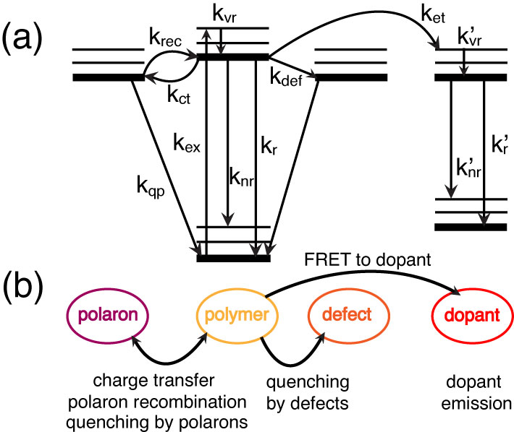

Fig. 1.1. (a) Jablonski diagram illustrating the exciton decay processes in doped CPNs. (b) Illustration relating the rate processes in (a) to their respective physical observables.

After vibrational relaxation to the ground vibrational state of the excited electronic state (kvr), an exciton may either decay radiatively (kr), or non-radiatively via internal conversion (knr). The exciton may also undergo Förster resonance energy transfer (FRET) to a defect site (kdef) where the exciton is quenched. Excitons may undergo charge transfer to form hole polarons (kct, discussed later), or the hole and electron recombine to reform the neutral exciton (krec). If subsequent excitons are generated in the vicinity of a polaron, they may be quenched by the polaron (kqp). If a dopant species is introduced into the system, an exciton may undergo FRET to the dopant (ket, discussed below), where similar processes apply if the dopant is a conjugated polymer, or radiative and non-radiative decay may occur if a fluorescent dye dopant is used.

* 1. **Conjugated Polymer Device Structure**

Conjugated polymers have been utilized in several device types including photovoltaics and LEDs. Thin films are used in these devices in order to minimize device size and due to the need to layer active materials specifically for electron and hole injection and transport, or as an emissive material layer. In a typical organic photovoltaic (c.f. Fig 1.1), a substrate such as glass is deposited with several thin films, the first being an optically transparent conducting anode material that acts as a hole injection material (e.g. indium tin oxide, ITO). Due to the efficiency of energy transport and hole transport, hole-conducting CPs such as the ones used in this research would comprise the hole transport material in these devices. An efficient electron transport layer material (e.g. thiophene polymer, fullerene polymer) is blended with the hole transport material in the same solution, and then the blend is deposited on top of the cathode, forming a bulk heterojunction. A metal cathode (typically aluminum) is deposited on top of the bulk heterojunction. In these devices, neutral photoexcitations known as Frenkel excitons (described in the next section) are generated in the bulk heterojunction where the hole and electron transport materials overlap, and the neutral exciton is separated into individual charges (electrons, holes) via charge transfer. The electron and hole are then transported through the respective transport layers to the cathode or anode, generating electrical current in the device. {Heeger, 2014 #193}{Günes, 2007 #191}{Adams, 1999 #1} Running a similar device in reverse produces light (as charges recombine and excitons decay radiatively), and is the basis of organic LED technology. The efficiency of these devices is determined partially by the work functions of the cathode and anode materials, as well as the efficiency of charge transfer and recombination. Typical power conversion efficiencies for these devices are up to ~9% for OPVs (similar to quantum dot based PVs), and up to 8% for OLEDs (compared to ~10% for quantum dot LEDs).{Dennler, 2005 #10}{Günes, 2007 #191}{Chuang, 2014 #229}{Cao, 1999 #192}{Heeger, 2014 #193}{Shen, 2015 #230}

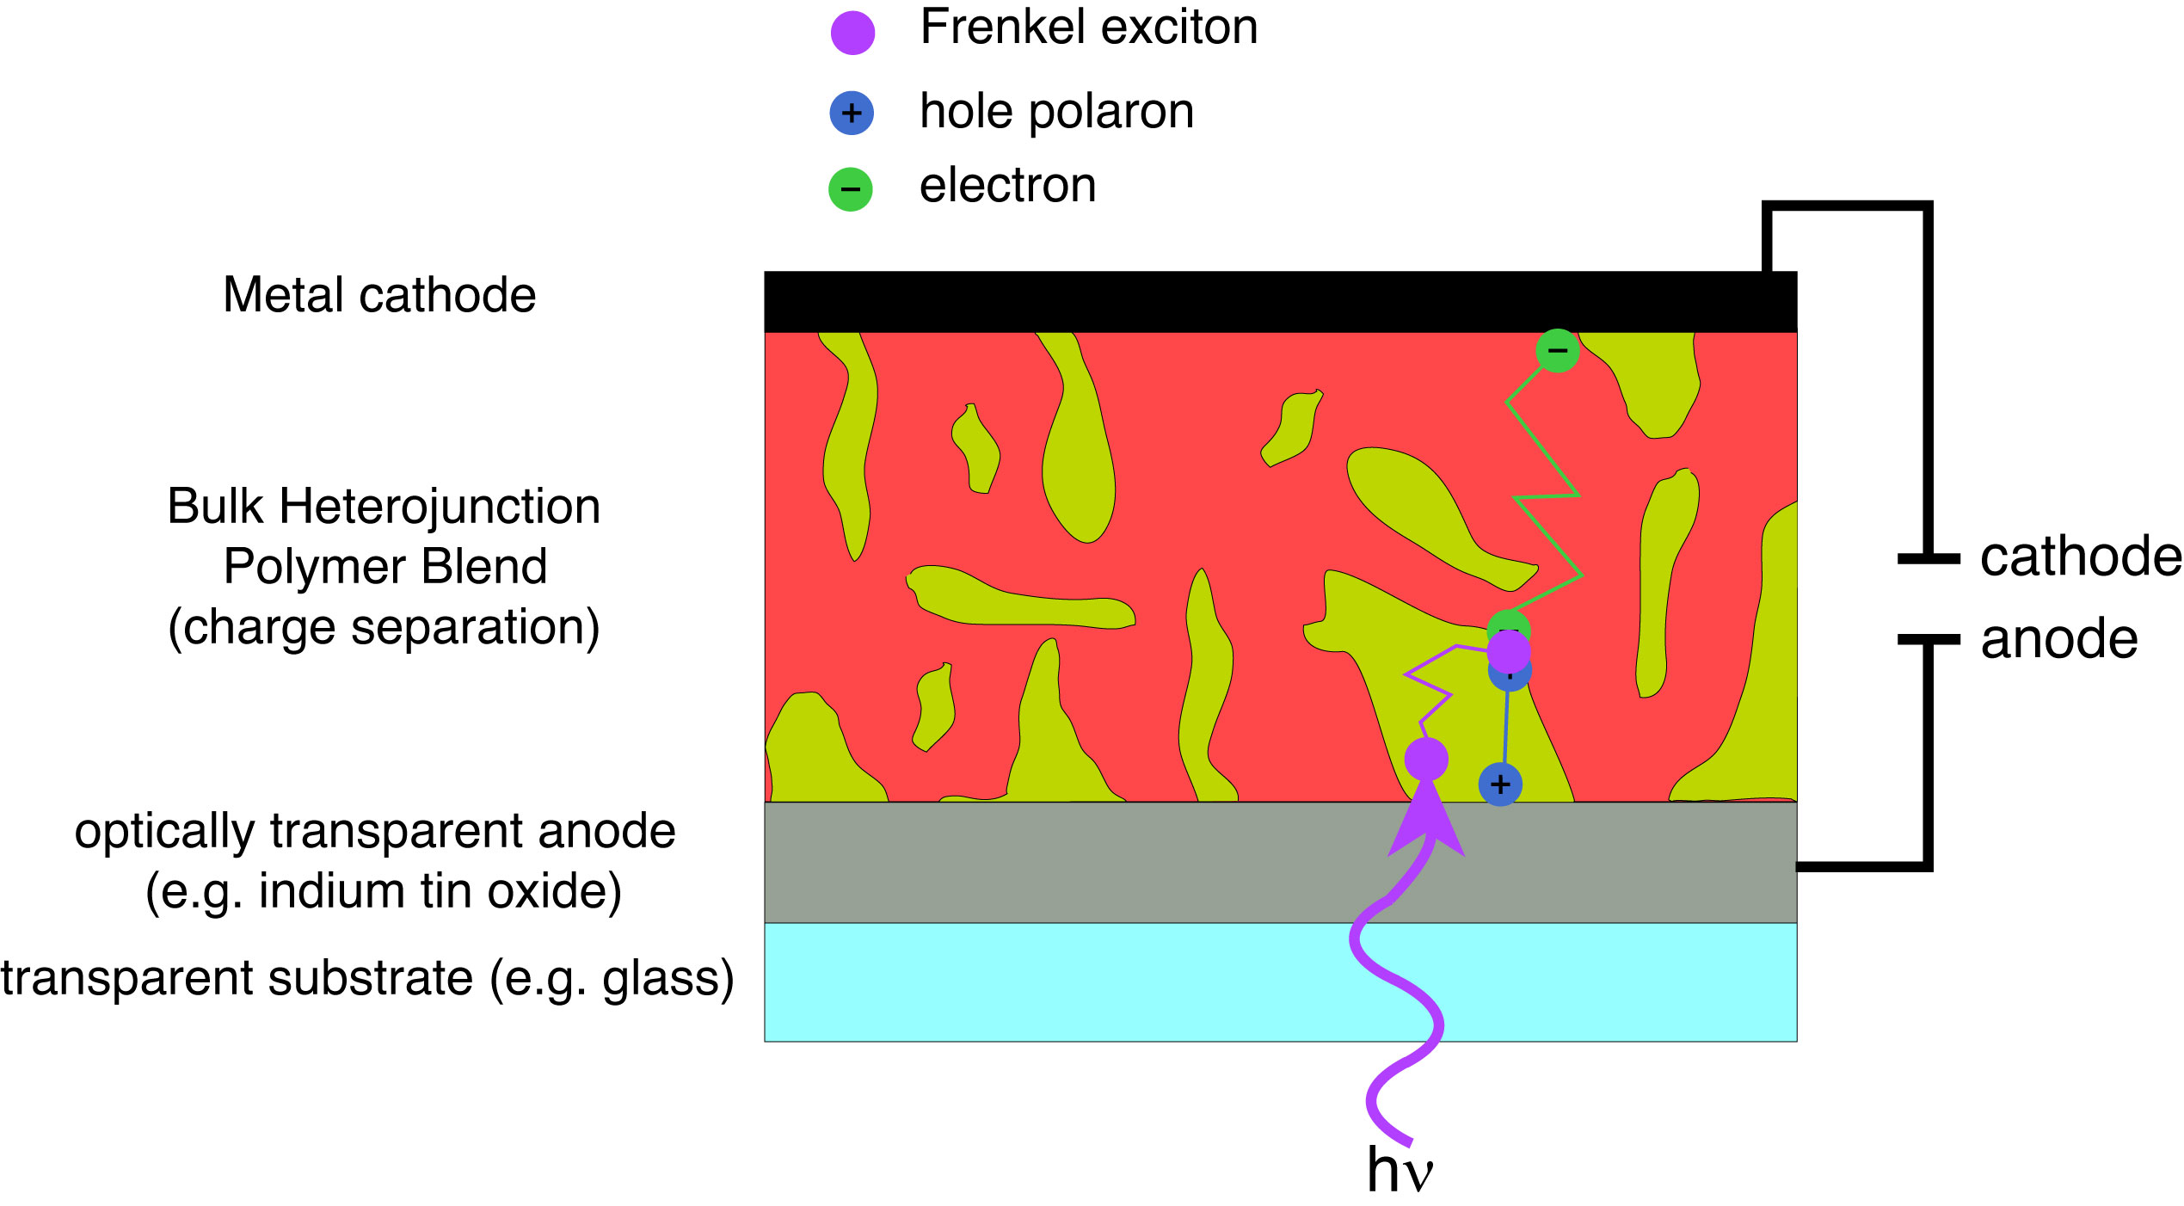

Fig. 1.2. Schematic of a bulk heterojunction organic photovoltaic/LED device depicting exciton generation and exciton, electron, and hole transport.

* 1. **Förster Resonance Energy Transfer (FRET)**

FRET and Dexter electron transfer are processes involving the incoherent transfer of an electronic excitation from molecule to another. If transfer occurs between like molecules (e.g. equivalent chromophores of a conjugated polymer), this is referred to as homotransfer or homo-FRET. If transfer occurs between chemically distinct molecules, this is referred to as heterotransfer/hetero-FRET. For each transfer process, the molecule initially excited by photon absorption to its singlet excited state is referred to as the donor, and the molecule that the excitation is transferred to is referred to as the acceptor. All of the aforementioned processes are non-radiative (there is no photon emission upon donor relaxation nor reabsorption of emission resulting in acceptor excitation), and have similar initial and final states. However, the path by which an excitation moves from one molecule to another differs between FRET and Dexter transfer. The differences between each process are discussed in detail below, and illustrated in Fig. 1.3.

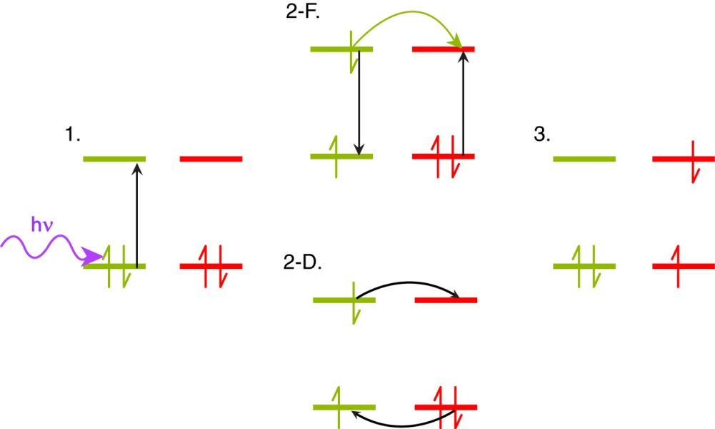

Fig. 1.3. Comparison of Förster and Dexter transfer, including illustration of the HOMO and LUMO orbitals of a donor (yellow) and acceptor (red) pair, with colored arrows to indicate photon absorption (purple), energy transfer (yellow), and electron motion (black). In the initial state (1), a HOMO donor electron is excited to the LUMO via photon absorption. The intermediate states illustrate the Förster resonance energy transfer (2-F) and Dexter electron transfer (2-D) processes. Both processes yield the same final state with the donor in the ground electronic state and an electron in the acceptor LUMO (3).

The process of FRET involves long-range (≤10 nm) transition dipole coupled energy transfer from the donor to the acceptor, resulting in non-radiative relaxation of the donor electron from the excited state back to the ground state, and concomitant HOMO🡪LUMO excitation in the acceptor.{Förster, 1948 #181} The FRET process is dependent upon several variables, including intermolecular separation, spectral overlap of the donor fluorescence spectrum with the acceptor absorption spectrum, and relative alignment of transition dipole moments between the donor and acceptor. It is convenient to define a distance *R*0 known as the Förster radius, where FRET between the donor and acceptor is 50% efficient (typically 1-6 nm).{Wiczk, 1991 #206}{Akrap, 2010 #207} Förster posited that, under favorable conditions, the transition dipoles of nearby chromophores can couple in such a way as to lead to energy transfer. Due to the dipole-dipole nature of the interaction, the rate of ET is given by

, (1.9)

where *R* is the intermolecular separation and 0 is the fluorescence lifetime of the donor. *R*0 depends on the spectroscopic properties of the donor and acceptor, including the spectroscopic overlap. If the spectra are given as a function of wavelength in nm, then R0 is given by

, (1.10)



where *n* is the refractive index of the solvent, *N* is Avogadro’s number, *D* is the fluorescence quantum yield of the donor (a measure of the percentage of photon absorption events that result in fluorescence photons). **2 is the transition dipole orientation factor (typically assumed to be 2/3 for random transition dipole orientations), given by

, (1.11)



where the angle ** corresponds to the angle between the donor and acceptor transition dipole vectors, ** corresponds to the angle between the donor transition dipole vector and the intermolecular axis, and ** corresponds to the angle between the acceptor transition dipole vector and the intermolecular axis (c.f. Fig 1.4).

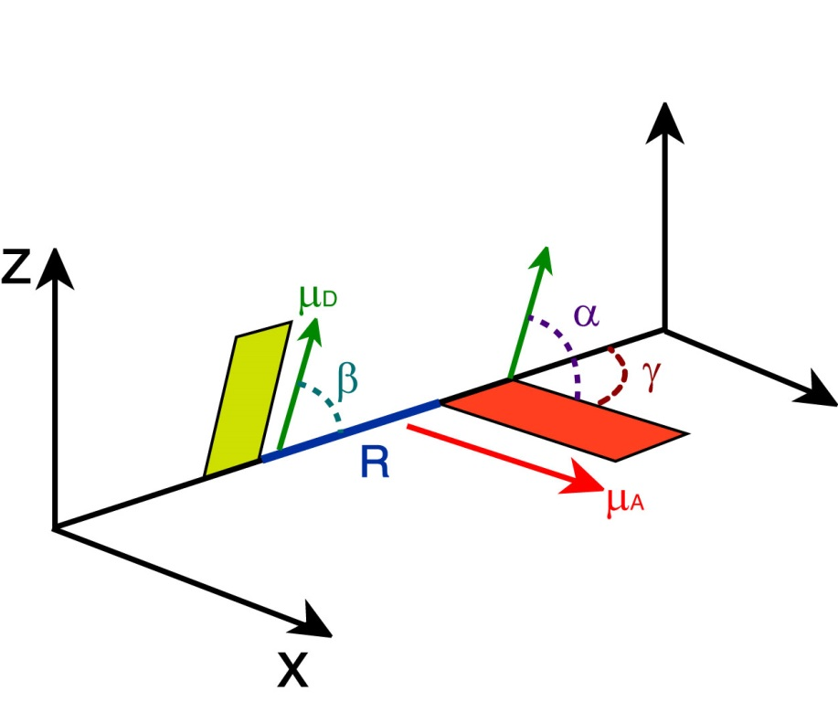

Fig. 1.4. Illustration of transition dipole vectors and angles used to calculate **2 for a donor and acceptor pair. D (green) and A (red) correspond to the donor and acceptor transition dipole vectors, R (blue) is the intermolecular distance along the intermolecular axis.

Lastly, *J*(**) is the spectral overlap integral, calculated by

, (1.12)



where ** and *d* are the wavelength and wavelength spacing, respectively, *FD*(**) is the normalized emission spectrum of the donor, and *A*(**) is the extinction spectrum of the acceptor (converted from the absorption spectrum using Beer’s Law). FRET is a useful tool for measuring interactions between molecules for distances <10 nm, and is often referred to as a “molecular ruler.”{Stryer, 1967 #172}{Stryer, 1978 #173}{Lakowicz, 2006 #26}

The dependence of the FRET rate constant on the inverse sixth power of intermolecular separation arises initially from the fact that FRET is facilitated by interacting excited-state transition dipoles, which is taken to be a first-order perturbation between the excited donor and acceptor, described as follows. From the time-dependent tunneling example described in section 1.3 (c.f. Equation 1.X), we see that the tunneling probability amplitude . Using a Fermi’s Golden Rule approach, we can approximate the sine function at early times as and thus . Thus the interaction potential is squared, yielding an *R*-6 proportionality in the tunneling rate.{Loudon, 2000 #233} The distinction of Förster transfer from previously mentioned coherent transfer is that Förster transfer is assumed for weakly coupled transition dipoles (and/or higher disorder), whereas coherent transfer requires strong coupling. Depending on the magnitude of the coupling strength , the expansion coefficients corresponding to the mixed state vary. If is weak compared to the energy difference between coupled states, the reflect this by having most of the excitation on one chromophore, and the other near zero (the exciton is shared incoherently, as in homo-FRET). For perfect degeneracy and/or strong transition dipole coupling, the excitation is shared equally amongst the participating chromophores (, where *N* is the number of coupled chromophores).

* + 1. **Dexter Electron Transfer**

Despite sharing the same initial and final states with regard to donor and acceptor as FRET, the mechanism of Dexter transfer differs substantially from FRET. In Dexter transfer, an electron in the ground state (HOMO) of the acceptor is exchanged with an electron in the excited state (LUMO) of the donor. These electrons possess identical spins, and remain in similar electronic states (a LUMO donor electron is transferred to the LUMO of the acceptor, and a HOMO electron in the acceptor is transferred to the HOMO of the donor). The spin criterion holds true for singlet Dexter transfer, but not for triplet transfer, or triplet-triplet annihilation,{Monguzzi, 2008 #180} in which the transferred electrons possess opposite spins. The Dexter process is facilitated by molecular orbital (wavefunction) overlap, as well as spectral overlap of the donor fluorescence spectrum with the acceptor absorption spectrum. Given the former criterion, the Dexter transfer mechanism is very sensitive to changes in intermolecular separation. The distance-sensitivity of Dexter transfer is made clear upon inspection of the probability of electron exchange, given by:

, (1.13)



where *Z* is a constant (1), *J*(**) is the is the normalized spectral overlap integral given by Equation 1.3, *R* is the intermolecular separation (in angstroms), and *L* is the average of the van der Waals radii of the donor and acceptor (in angstroms).{Dexter, 1952 #176} Inspection of the exponential term alone in Equation 1.5 elucidates the distance sensitivity of Dexter transfer. Depending on the average van der Waals radius *L*, the probability of electron exchange falls to essentially zero within ~1-2 nm or less, and is reduced further depending on the spectral overlap and *Z*, proving that Dexter transfer is only efficient at very small intermolecular separations. However, for cases in which chromophores are tightly packed and Förster transfer is not favored (for example, due to unfavorable dipole alignment, or in the case of triplet excited states, which exhibit low acceptor extinction), Dexter transfer may be the dominant energy transfer mechanism.{Scholes, 2000 #227}

* 1. **Polarons in Conjugated Polymers**

Devices based on CPs require efficient charge transport in addition to efficient exciton transport in order to function properly. In these devices, charges are either injected into the polymer through cathode/anode materials, or formed by dissociation of excitons through charge transfer events in the bulk heterojunction (c.f. section 1.3). Additionally, many fluorescence measurements on conjugated polymers and nanoparticles are complicated by photoejection of charges at higher excitation powers, resulting in a leftover isolated charge on the polymer chain that quenches the excited state via charge-transfer complex formation or damages the polymer resulting in photobleaching. These molecular ions along with the polarized volume surrounding them within the polymer are treated as quasiparticles and referred to as polarons.

The majority of measurements performed in this research were performed in air, and thus the presence of oxygen provides an oxidizing environment. This is combined with the fact that under ambient conditions, the CPs used in this study are inherently hole-conducting/electron donating. As such, hole polarons are assumed to be the prominent type of polaron occurring in these CPs. However, under reducing conditions, or by using intrinsically electron-conducting conjugated polymers based on perylene diimide structures, or based on fullerenes such as PCBM, electron polarons can be more prominent.{Meng, 2010 #245}{Brabec, 2001 #200}{Bakalis, 2014 #201} Hole polarons can recombine with electrons to reform Frenkel excitons, and the combined processes of exciton dissociation and charge recombination (together with luminescence quenching by polarons) lead to blinking phenomena in CP single molecules and CPNs. {Barbara, 2005 #198}{Yu, 2012 #58}{Lin, 2008 #199} Polaron formation introduces red-shifted features into CP absorption spectra that overlap with the emission spectra.{Tessler, 1998 #239} Thus, the spectral overlap of hole polaron absorption with CP emission yields efficient FRET to polarons, substantially quenching fluorescence (and causing blinking when polarons are generated and recombine rapidly). In early device work, it was thought that quenching of emission in CP thin film devices was due to field-induced dissociation of excitons using modest voltages,{Lee, 1994 #258} under the assumption that Frenkel excitons in CPs possessed similar binding energies to Wannier excitons in inorganic semiconductors (~0.01 eV), {Blossey, 1971 #259} which are typically only stable at low (a few K) temperatures.{Scholes, 2006 #36} However, later work by Bässler and others indicated that Frenkel excitons have much higher binding energies (~0.1-0.5 eV), and that emission quenching was due to high densities of hole polarons in the device acting as efficient fluorescence quenchers.{Barth, 1997 #257}{McNeill, 2001 #244} Indeed, polarons are able to quench ~90% of the fluorescence of a CP chain consisting of ~103 chromophores, and they can possess quenching volumes as high as ~400 nm3, making them extremely efficient fluorescence quenchers.{McNeill, 2001 #244}{Yu, 2004 #171}{Yu, 2012 #58} Polaron quenching becomes significant at a density of 5x1017 polarons/cm3, which is typically exceeded in devices.{McNeill, 2002 #1282}{Deussen, 1995 #1262} In addition, polarons can diffuse throughout the conjugated polymer medium, given that conjugated polymers are disordered semiconductors. The localized quenching behavior of hole polarons has also been exploited for tracking of charge carrier motion in CPNs, {Yu, 2009 #57}{Yu, 2012 #58} and can be utilized to determine the rates of polaron generation and recombination in CPNs via determination of blinking rates using single molecule fluorescence microscopy.

* 1. **Aggregate Species in Conjugated Polymer Nanoparticles**

Conjugated polymer nanoparticles are comprised of one or more collapsed CP chains. Given the dramatic increase in chromophore density, energetically favorable interactions between many closely spaced chromophores lead to the formation of aggregate species. These aggregate species can be in the form of H- or J- aggregates, excimers, or exciplexes.{Hayer, 2012 #18}{Jelly, 1937 #21}{Jenekhe, 1994 #183} These interacting species are given in detail below. In addition to the aforementioned aggregate species, conformational variability introduced upon chain collapse (e.g. bending/kinking of the polymer backbone) breaks up the conjugation along the polymer backbone. All of the aforementioned interactions yield changes in the emission characteristics of CPNs compared to polymer in good solvent (i.e., shifting and inhomogeneous broadening of the nanoparticle absorption and emission spectra, as well as increased lifetime heterogeneity), where aggregates and their corresponding photophysics contribute in greater proportion overall than conformational variability to the changes in CP photophysics upon nanoparticle formation.

The differentiating characteristics between H- and J-aggregates are their structural alignments, spectral shifts (that arise from the orientation of coupled transition dipoles), and fluorescence lifetimes. As previously mentioned, H- and J-aggregates both arise from Davydov splitting effects resulting from favorably arranged transition dipoles between interacting chromophores (the Frenkel exciton picture described in Section 1.2). While transition dipole orientation-dependence is implicit in the Frenkel picture, modern studies on H- and J-aggregates often prefer to discuss orientation dependence directly through the structural alignment of the interacting molecules, known as the “slippage angle.” This is the angle formed by the long axis of one molecule, and the line connecting the centers of the molecules. For high slippage aggregates (angles < 54.7°), the transition dipoles are aligned in a head-to-tail orientation, which leads to J-aggregate spectral characteristics. For low slippage aggregates (angles > 54.7°), the transition dipoles are in parallel orientation, leading to H-aggregate spectral characteristics (c.f. Fig 1.5).{Wurthner, 2011 #140} In H-aggregates, the absorption and fluorescence spectra are shifted toward higher energy (hypsochromically shifted or blue-shifted) and the emission spectrum is broadened. The lifetimes of H-aggregates are also either similar to or longer than that of the monomer.{Clark, 2007 #189}{Maiti, 1997 #187}{Chaudhuri, 2011 #188} In contrast, J-aggregates exhibit bathochromically shifted (shifted toward lower energy or red-shifted) absorption and emission, with a narrowing of the emission band, an increase in fluorescence quantum yield, and a substantial reduction in lifetime compared to the monomer. (While Scheibe and Jelley both independently discovered J-aggregates in the same year, Jelley is formally credited for their discovery through their nomenclature, and Frenkel developed the quantum mechanical description).{Jelly, 1937 #21}{Scheibe, 1937 #185}{Wurthner, 2011 #140}{Kometani, 2000 #24}{Frenkel, 1931 #224} The energy shifting in H- and J-aggregates results from exciton formation between the aggregated chromophores resulting in Davydov splitting into a higher and lower energy state relative to the degenerate monomers. Calculating the transition dipole moment for the higher and lower energy states in each case determines the optically allowed transitions for both aggregate species (c.f. Section 1.2), with the allowed transition for each case being the transition to the higher energy state for an H-aggregate, and the lower energy state for a J-aggregate. These states correspond a nonzero vector sum of transition dipoles (parallel transition dipole arrangement for H-aggregates, head-to-tail arrangement for J-aggregates), whereas the opposite states yield transition dipole vector sums of zero (antiparallel transition dipole arrangement for H-aggregates, head-to-head transition dipole arrangement for J-aggregates), forming dark exciton states.{Köhler, 2015 #184}{Kasha, 1963 #186}

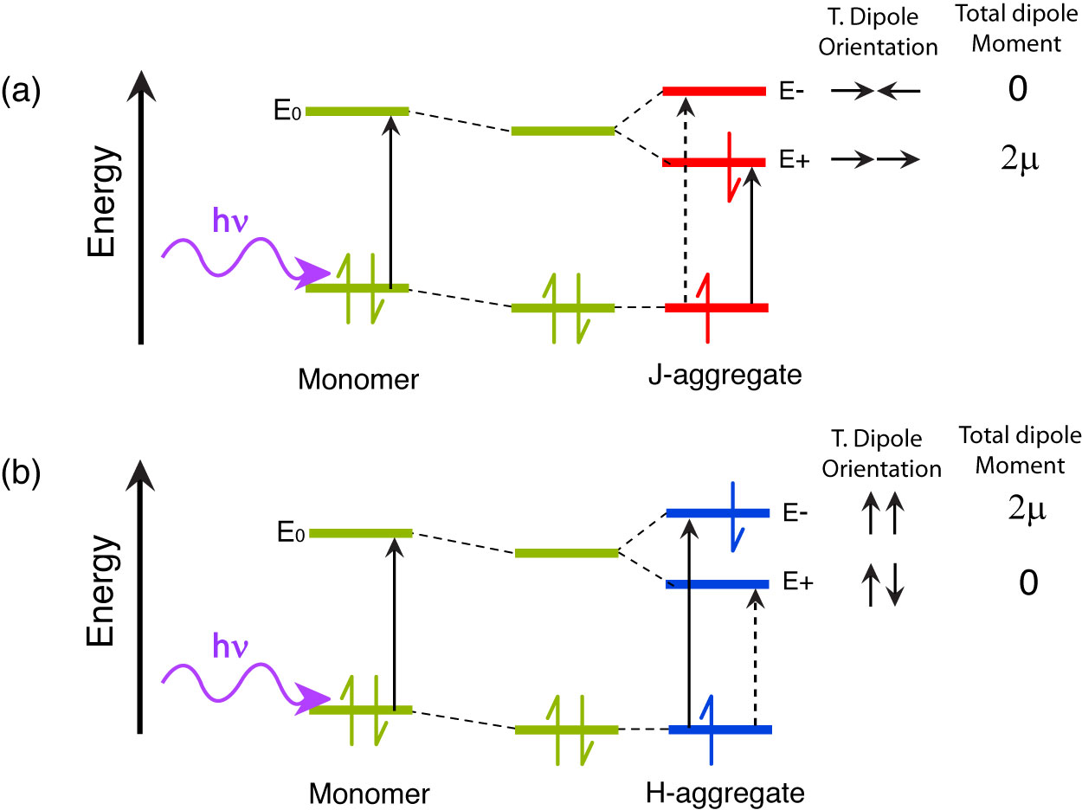

Fig 1.5. Molecular orbital illustration of ideal (a) J-aggregate and (b) H-aggregate states. Transition dipole coupling stabilizes the dimer. The allowed transitions for each aggregate are given by the solid black arrow, and forbidden transitions are given by a dashed black arrow. Transition dipole orientations and total dipole moments are given to the right of each M.O. diagram.

Excimers (excited dimers) and exciplexes (excited complexes) are another pair of aggregate species in CPs, and both result from an interaction of one molecule in its excited state with another molecule in its ground state. Excimers result from RET and/or electron transfer interactions (due to orbital overlap) between like molecules to form an electronically neutral dimer (similar to H- and J-aggregates, except that there is a net, though possibly slight, bonding interaction due to orbital overlap, and the ground state is dissociated, which gives rise to a characteristic broad, red-shifted spectrum). The main factors that impact whether excimers or H- or J-aggregates form includes the structural arrangement of the molecules, the relative transition dipole coupling strength between the interacting monomers, and whether there is a net bonding interaction in the excited state, (i.e., intermolecular bonding via a pi* orbital). Excimers and H-aggregates form under similar structural arrangements; however, excimers have several differentiating characteristics from H-aggregates. Unlike H-aggregates, constituent monomers of an excimer are only electronically coupled in the excited state, possessing a weak bonding interaction in the excited state, and a dissociative ground state (the individual molecules of the dimer repel following emission). In addition to the dissociative ground state, the other distinguishing photophysical features of excimers include a broad, red-shifted emission spectrum (due to the electronic stabilization of the dimer upon formation) lacking vibronic structure, and a substantial reduction in fluorescence lifetime.{Köhler, 2015 #184} Exciplexes are formed by electron transfer between two chemically distinct molecules (e.g. following charge transfer in a bulk heterojunction), where the excited electron donor becomes positively charged, and the electron acceptor becomes negatively charged. Formation of the charge-transfer state results in either back-transfer to reform either the ground state or the Frenkel exciton on the donor, or coulombic attraction between the electron/hole pair to form the exciplex. Like excimers, exciplexes have a dissociative ground state following emission, and exhibit broad, structureless, red-shifted emission due to energetic stabilization of the charge-transfer complex. However, in contrast to excimers, exciplexes have longer lifetimes, where the exciplex state is either similar in lifetime or much longer-lived compared to the lifetime of the donor molecule, as well as a reduced fluorescence quantum yield.{Köhler, 2015 #184}{Jenekhe, 1994 #183}{Müllen, 2006 #232} Due to the conditions required for efficient electron transfer (c.f. section 1.4), exciplexes form most efficiently for arrangements of donor and acceptor that maximize molecular orbital overlap (c.f. Fig 1.6). Exciplexes also tend to be favored in nonpolar solvents, as polar solvents stabilize the interacting charges leading to solvent-separated ion pairing and exciplex quenching.{Ghoneim, 2001 #190}

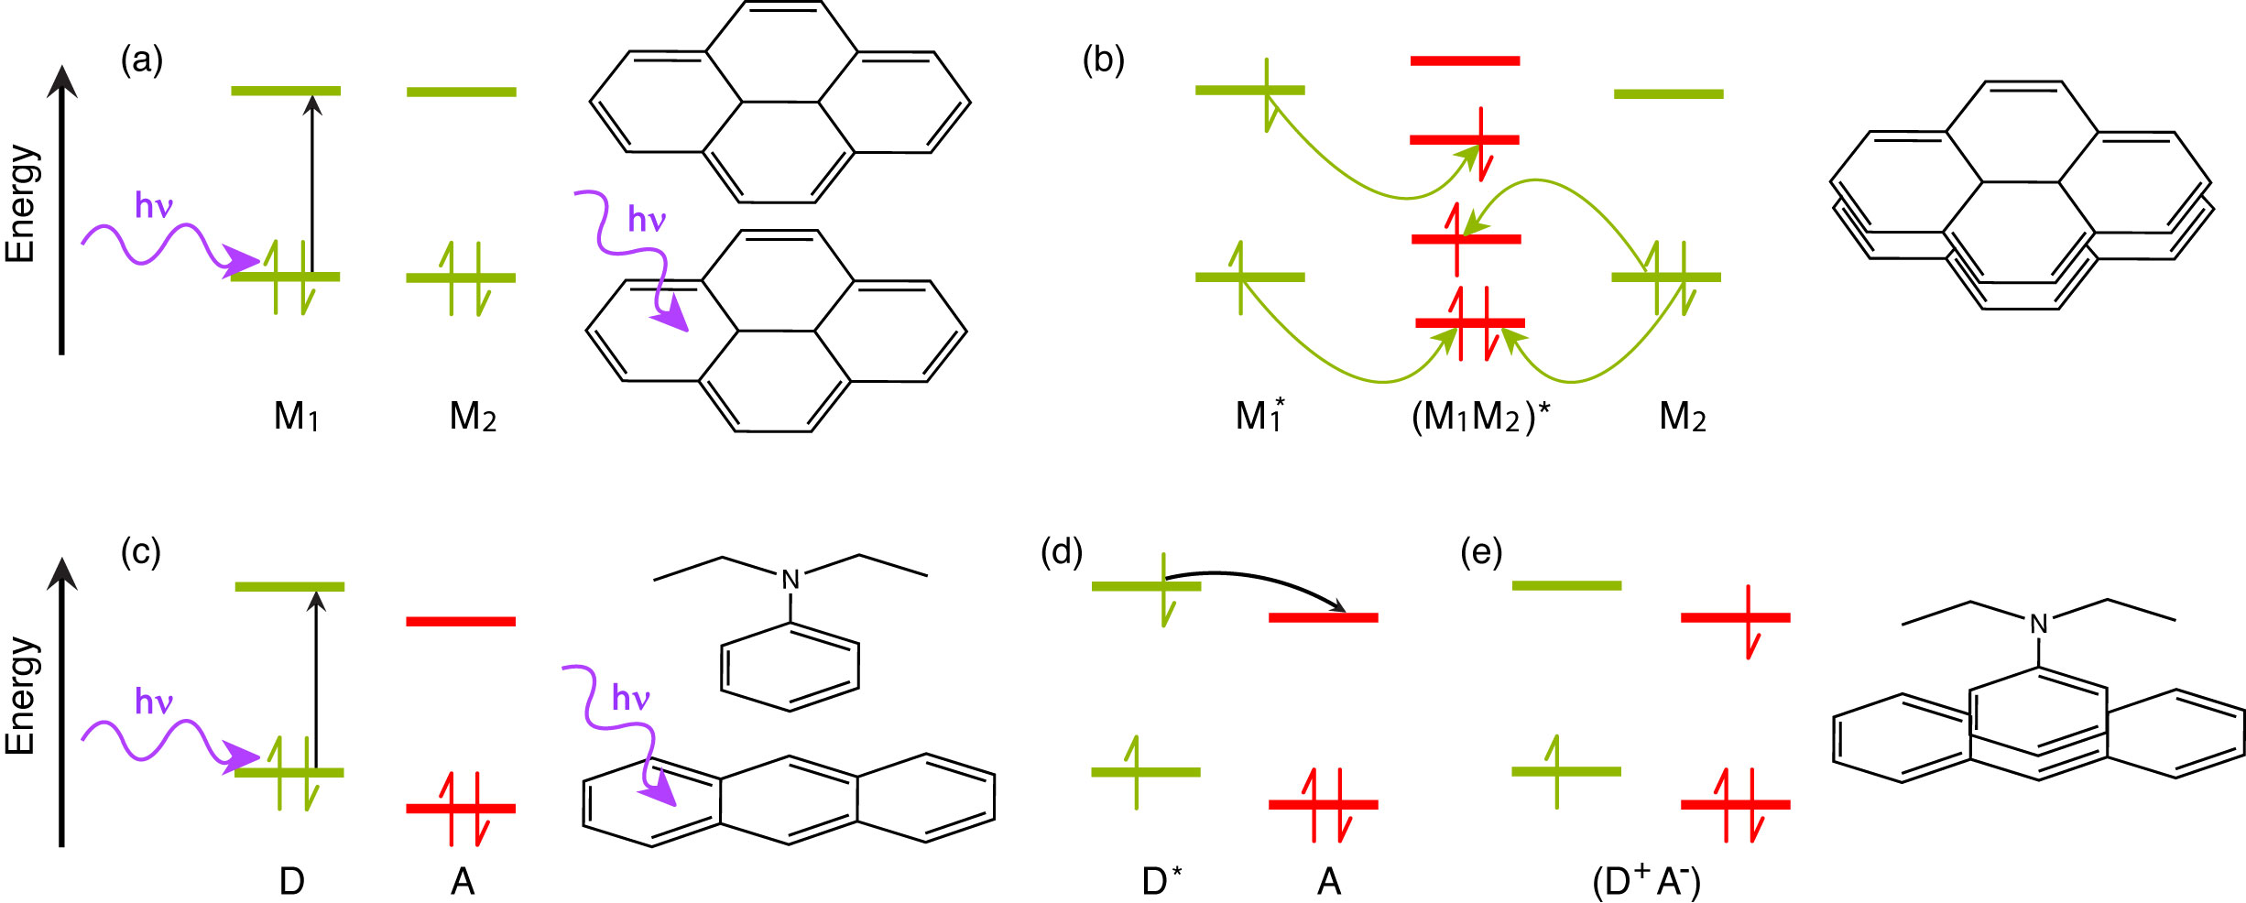

Fig. 1.6. Molecular orbital illustration of excimer (a, b) and exciplex (c-e) formation, accompanied by molecular illustrations of pyrene excimer formation (top) and anthracene/N,N-diethylaniline exciplex formation (bottom). In the excimer case, two like molecules M1 and M2 interact, with (a) M1 initially excited to M1*, followed by (b) RET (yellow arrows) to form a neutral excited dimer (M1M2)* (though RET may be replaced by electron transfer). In the exciplex case, two distinct molecules, one electron donor D and one electron acceptor A interact. (c) The donor is excited from D to D*, followed by (d) electron transfer (black arrow) from D* to the acceptor A to form an excited state charge-transfer complex (D+A-).{Köhler, 2015 #184}

* 1. **Measurement of Exciton Diffusion Length**

For some device types, it is required for excitons to travel long distances over the course of their excited state lifetime for optimum device efficiency (i.e., excitons must travel far enough to encounter a bulk heterojunction, so that charge transfer can occur, as in organic photovoltaics). In the experiments detailed in the later chapters of this dissertation, we aim to determine the length scale in which exciton diffusion occurs in conjugated polymer nanoparticles. Given the difficulty in determining the exciton diffusion constant directly, the quantity typically reported instead is the exciton diffusion length, *LD*. The relationship between *LD* and the diffusion constant *D* is derived from Brownian motion theory, which assumes that diffusion is given by Gaussian probability distribution function, given in 1D by

, (1.14)

where *x*0 is the initial position of a particle at time *t*0, *x* is the positon at a later time *t*, and

, (1.15)

where *D* is the diffusion constant. Extending Equation 1.15 to the exciton diffusion picture, and accounting for the probabilities of radiative decay and energy transfer over the course of the excited state lifetime, the diffusion length is given by

, (1.16)

where *n* is the dimensionality ( *n* = 1, 2, 3), and ** is the exciton lifetime.

While Wannier excitons in crystalline inorganic semiconductors can possess diffusion lengths of several microns,{Stokes, 1977 #248} (Frenkel/molecular) exciton diffusion lengths in organic semiconductors are typically much shorter. For example, measured exciton diffusion lengths for single crystals of anthracene range from ~30 nm to 60 nm,{Donati, 1978 #1263}{Mulder, 1967 #1285}{Simpson, 1957 #1290} and diffusion lengths of under 15 nm are typically reported for conjugated polymers.{Lyons, 2005 #1280}{Wu, 2008 #1297}{Tousek, 2012 #1294} The probability of energy transfer to polarons, chemical defects, and aggregate species (resulting from chromophore interactions) can reduce the observed exciton diffusion length. There are various experimental methods employed to characterize exciton diffusion in organic semiconductors that lead to a wide range of reported exciton diffusion lengths due to various experimental complications.{Lunt, 2009 #262} Many of the reported exciton diffusion lengths have been determined via various thin film methods, such as doped thin films, or photoluminescence quenching in bilayer device structures (where the donor/exciton transport layer and acceptor/quencher layer exist as adjacent thin film layers). {Gregg, 1997 #17}{Lunt, 2009 #1279}{Hofmann, 2012 #1270} However, these methods are complicated by several factors, including pinholes in the film (that lead to direct excitation of the acceptor layer), quenching by surface plasmons from the metal contacts, interdiffusion of the quencher layer into the donor layer (i.e. poor layer segregation), waveguiding effects, and that the optical penetration depth (given by the inverse of the absorption coefficient of the material at the respective wavelength) is often significantly larger than the diffusion length of the material. It is also possible to image exciton diffusion with methods such as near-field scanning optical microscopy (NSOM),{McNeill, 2000 #32} but diffraction becomes an issue in that it places a lower limit on the measureable diffusion length (~50 nm). The experiments in this dissertation determine the exciton diffusion length indirectly with time-resolved fluorescence spectroscopy, in conjunction with a model based on a Monte Carlo approach with a random-walk algorithm (given in detail in later chapters).

Exciton diffusion in CPNs involves both diffusion-like transport processes and decay to quenchers (e.g. defects, dopants). The simplest version of this physical picture involves modeling a series of excitons undergoing random walk trajectories in the presence of a single point-like quencher. The analytical solution for diffusion and decay from a point source (or to a point sink) is proportional to the zero-order Modified Bessel Function of Second Kind (*K*0, which decays exponentially). At steady-state, diffusion and decay from a point source/sink is given in 3D by

, (1.17)

in 2D by

, (1.18)

and 1D by

, (1.19)

where *n* is the density of excitons that have decayed at distance *R* (or *x* in 1D) from the point source, *n*0 is the initial density of excitons at the source, and *LD* is the exciton diffusion length. Our exciton diffusion energy transfer model is tested using decay to a point sink (assuming *LD* = 3 nm, and a single quencher of Förster radius of 0.1 nm for the sink). The results for 3D exciton diffusion and decay from our model (with comparison to Equation 1.17) indicate that the model reproduces diffusion and decay accurately (c.f. Fig. 1.5).

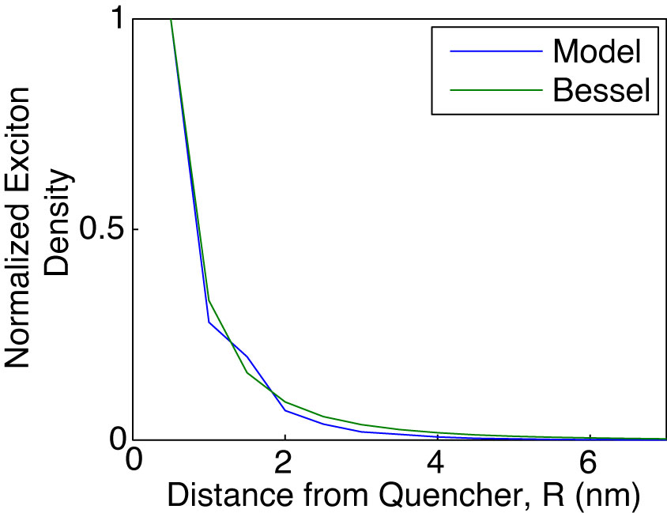

Fig. 1.5. Density of decayed excitons as a function of distance from a point-like sink (quencher with *R*0 = 0.1 nm) from the exciton diffusion energy transfer model (blue), with comparison to Equation 1.17 (green).

* 1. **Fluorescence Anisotropy Decay in Conjugated Polymer Nanoparticles**

Exciton transport in conjugated polymers and nanoparticles is the result of multiple energy transfer events between (essentially) equivalent chromophores. In these systems, energy transfer is more or less indistinguishable from one event to the next, and while steady-state UV-Vis and fluorescence can help to elucidate significantly different species in the ensemble via their spectral signatures (e.g. H-/J-aggregates, chemical defects), and decay rates can be probed by measuring fluorescence lifetimes for each distinguishable part of the ensemble, it is not possible to determine average energy transfer rates between equivalent chromophores using these methods. By examining changes in the polarization of the time-resolved fluorescence signal, it is possible to probe the rate of energy homotransfer (in the absence of rotational diffusion), and reveal underlying relationships between exciton transport rates and corresponding physical observables (e.g., differences in quenching between CPNs and CPs in solution, differences in fluorescence quantum yield and lifetime for similar polymers, etc.).

Fluorescence anisotropy is a measure of the average polarization of fluorophore emission upon excitation with plane-polarized light. Typically, the excitation source is linearly polarized, and the emission is analyzed after being passed through a linear polarizer oriented parallel (0°) or perpendicular (90°) relative to the excitation source. These components of the emission are given by and , respectively, and the anisotropy *r* is then calculated by



, (1.17)



which forms a ratio of the difference between the parallel and perpendicular emission components relative to the total intensity. Extending this into the time domain, 1.6 becomes

, (1.18)



where *r*(*t*) is the fluorescence anisotropy decay (FAD), *D*(*t*) is the difference in the parallel and perpendicular components of the emission (given by  and, respectively), and *S*(*t*) is the total polarized fluorescence intensity, given as the sum of the parallel component of the emission, and the two perpendicular components of the emission. FAD allows us to quantify the rate at which different processes (e.g. rotation, multiple energy transfer) cause depolarization of the fluorescence signal. It is worth noting that the relative amplitude of cos2** and sin2**, where ** is the angle of the emission polarizer. When the emission polarizer is set to  = 54.7° (magic angle, ~55°), this results in cos2** = 0.333 and sin2**  , which corresponds to a twofold amplitude of the perpendicular component of the emission relative to the parallel component of the emission, or .{Lakowicz, 2006 #26} Thus, it is possible to measure the total intensity *S*(*t*) by magic angle orientation of the emission polarizer, and the anisotropy decay is calculated by



. (1.19)



Conformational variability in CPNs results in many closely-spaced chromophores in varied orientations in space. Thus, it follows that a linearly polarized excitation source (e.g. a pulsed laser) would preferentially excite certain chromophores (those with their transition dipole moments oriented similarly to the polarized excitation pulse). While FAD is typically used to measure rotational dynamics of small molecules in solution (or rotational dynamics in macromolecules such as proteins),{Cross, 1984 #87}{Beechem, 1985 #261} in an aqueous suspension of CPNs, particles are typically large enough that rotational diffusion at room temperature occurs on time scales several orders of magnitude slower than the lifetime of the nanoparticles (rotational correlation times are tens of ns to µs, depending on particle size, whereas CPN lifetimes are typically on the picosecond time scale). Thus, we assume that any depolarization of fluorescence can effectively be ascribed to energy homotransfer events. As previously discussed, exciton homo-transfer on the ps-ns time scale is typically driven by incoherent methods of energy transfer (e.g., FRET, Dexter transfer). Given that the interchromophore distance is minimal (~1 nm) and assuming sufficient spectral overlap, the efficiency of each energy transfer event is then essentially governed by the alignment of transition dipole moments, accounted for in the 2 term in equation 1.1, which need not be perfectly aligned for energy transfer to occur. Therefore, each energy transfer event depolarizes the resulting emission (c.f. Fig 1.8). While it is uncertain exactly how many energy transfer events are required to completely depolarize emission (for systems with randomly oriented transition dipoles such as CPNs and films), previous studies on MEH-PPV films by Bardeen et al. have attempted to elucidate this issue.{Gaab, 2004 #260} The rate of depolarization, and thus the rate of exciton motion (given by the inverse of the measured correlation time c) can be probed using picosecond fluorescence anisotropy decay. Using the assumption that the correlation time c is a measure of the time it takes for a single incoherent transfer event to occur in conjunction with the fluorescence lifetime , the average number of energy transfer events occurring within the fluorescence lifetime can be approximated by the ratio of the lifetime and correlation time. Taking the approximate number of incoherent transfer events with the exciton diffusion length *LD* (determined from numerical random walk simulations), the typical distance per energy transfer event can be determined (if ~3 transfer events occur within the fluorescence lifetime, with a 12 nm *LD*, this gives ~4 nm distance traveled per energy transfer event).

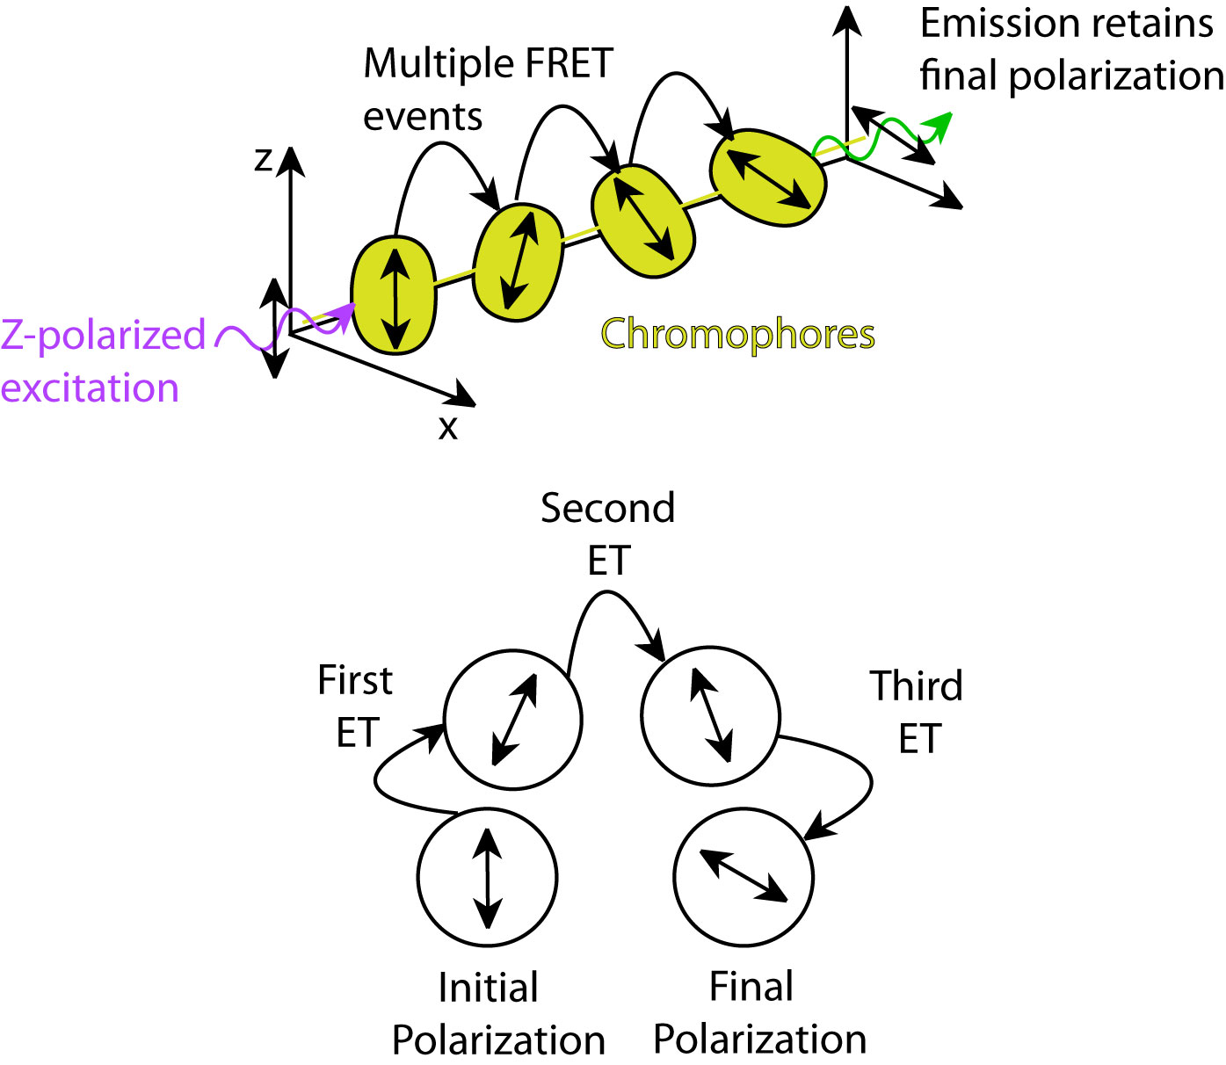

Fig. 1.8. Diagram depicting polarization loss via multiple energy transfer (top). Illustration of polarization changes after each FRET event (bottom).

The chapters within this dissertation principally focus on steady-state and time-resolved fluorescence spectroscopy of conjugated polymer nanoparticles and solutions with the goal of better understanding exciton transport in CPNs and related phenomena such as amplified energy transfer. Additionally, we examine the effects of nanoscale disorder on the excited state kinetics and spectra of CPNs. By understanding the various nanoscale interactions occurring in CPs and CPNs, we can better exploit the disorder in these materials to improve upon fluorescent probes and organic semiconductor devices. We also estimate the length scales of exciton transport in addition to the rates of exciton transport between CPNs and linear CPs to elucidate the relationships between nanoscale interactions and physical observables (such as fluorescence quantum yield and fluorescence lifetimes) in these systems. In addition, we aim to improve the fluorescence characteristics of CPNs (e.g. brightness and red-shifting of emission) for fluorescence imaging applications. Chapter 2 describes the materials, experimental methods, spectroscopic techniques, and instruments utilized in this research. Chapter 3 details the use of dye doping and polymer blending in CPNs with the aim of improving fluorescence brightness and red-shifting emission for fluorescence imaging applications, as well as to estimate the exciton diffusion length while accounting for defects in CPNs. Chapter 4 delineates the use of solvent-induced swelling coupled with time-resolved fluorescence anisotropy decay measurements to determine the rate of exciton transport in undoped CPNs compared to the linear polymer, as well as to assess the reversibility of quenching by defects via swelling. Both projects utilize a combination of steady-state and time-resolved spectroscopy in conjunction with Monte Carlo simulation to address these issues from multiple angles.